Pipe and Filter
# Source: AI Source: Provided by: [Data Path: Persons Table -> ID Column: 1, Name_En Column: Motasem Essam] -> From: [ChatGPT] on [1/23/2026]
Pipe and Filter is an architectural pattern where data flows through a series of processing steps (filters). Each filter transforms the data, and the output is passed through pipes to the next filter.
👉 Think of it like an assembly line: each step performs one task, and the result moves to the next step.

🔑 Key Idea
# Source: AI Source: Provided by: [Data Path: Persons Table -> ID Column: 1, Name_En Column: Motasem Essam] -> From: [ChatGPT] on [1/23/2026]
Break complex processing into small, independent steps, connected in a sequence.

🧱 Structure
# Source: AI Source: Provided by: [Data Path: Persons Table -> ID Column: 1, Name_En Column: Motasem Essam] -> From: [ChatGPT] on [1/23/2026]
Input → Filter1 → Filter2 → Filter3 → Output
- Filters → Perform transformations (processing steps)
- Pipes → Carry data between filters

🧩 Example (Data Processing)
# Source: AI Source: Provided by: [Data Path: Persons Table -> ID Column: 1, Name_En Column: Motasem Essam] -> From: [ChatGPT] on [1/23/2026]
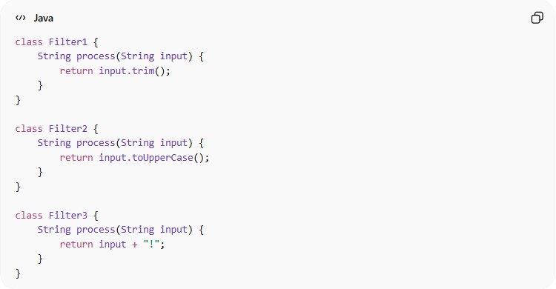
class Filter1 {
String process(String input) {
return input.trim();
}
}

class Filter2 {
String process(String input) {
return input.toUpperCase();
}
}

class Filter3 {
String process(String input) {
return input + "!";
}
}
Flow:
" hello " → "hello" → "HELLO" → "HELLO!"

❌ Bad Example (No Pipe & Filter)
# Source: AI Source: Provided by: [Data Path: Persons Table -> ID Column: 1, Name_En Column: Motasem Essam] -> From: [ChatGPT] on [1/23/2026]
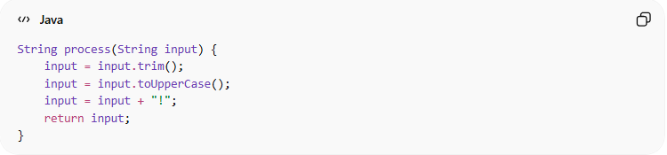
String process(String input) {
input = input.trim();
input = input.toUpperCase();
input = input + "!";
return input;
}
👉 Problems:
- All logic in one place
- Hard to reuse or modify steps
- Not flexible

✅ Benefits
# Source: AI Source: Provided by: [Data Path: Persons Table -> ID Column: 1, Name_En Column: Motasem Essam] -> From: [ChatGPT] on [1/23/2026]
- Easy to add, remove, or reorder filters
- Promotes reusability
- Each filter is independent and testable
- Good for data transformation pipelines

⚠️ Drawbacks
# Source: AI Source: Provided by: [Data Path: Persons Table -> ID Column: 1, Name_En Column: Motasem Essam] -> From: [ChatGPT] on [1/23/2026]
- Can introduce overhead (multiple processing steps)
- Not ideal for highly interactive systems
- Data format must be consistent between filters

⚡ When to Use
# Source: AI Source: Provided by: [Data Path: Persons Table -> ID Column: 1, Name_En Column: Motasem Essam] -> From: [ChatGPT] on [1/23/2026]
- Data processing pipelines
- Compilers (lexing → parsing → code generation)
- ETL systems (Extract → Transform → Load)
- Stream processing (logs, events, files)

💡 Key Idea
# Source: AI Source: Provided by: [Data Path: Persons Table -> ID Column: 1, Name_En Column: Motasem Essam] -> From: [ChatGPT] on [1/23/2026]
Each filter should do one thing only, making the system flexible and easy to extend.

🧾 Summary
# Source: AI Source: Provided by: [Data Path: Persons Table -> ID Column: 1, Name_En Column: Motasem Essam] -> From: [ChatGPT] on [1/23/2026]
Pipe and Filter helps you:
- Break complex logic into simple steps
- Build flexible and reusable processing pipelines
- Improve maintainability and testability

